**CONVERSATION ENGINE FOR DEAF AND DUMB USING IBM WATSON**

**Project Report**

**Department of Computer and Science Engineering**

**Chalapathi Institute of Engineering and Technology**

Team members

* T.Venkata Sri Vyshnavi
* V.Deepthi
* P.Lakshmi Radha
* P.Ramya

**INTRODUCTION:**

.

* HGRVC (Hand Gesture Recognition and Voice **Conversion**) system localizes and track the hand gestures of the **dumb** and **deaf** people in order to maintain a communication channel with the other people.
* The method gives output in text format that helps to reduce the communication gap between **deaf**-mute and people.

Purpose

* The only means of communication for **deaf and dumb** people is the **sign language**.
* This **application** helps the **deaf and dumb** person to com with rest of the world using **sign language**.

**LITERATURE SURVEY:**

**EXISTING PROBLEM:**

Different approaches are employed by completely different researchers for recognition of varied hand gestures that were enforced in numerous fields. The total approaches can be divided into 3 broad classes Hand segmentation approaches Feature extraction approaches and Gesture recognition approaches.

PROPOSED SOLUTION:

* Sign language is used as a communication medium among deaf and dumb people to convey the message with each other.
* In order to bridge the gap in communication among deaf , dumb community and normal community, lot of research work has been carried out to automate the process of sign language interpretation with the help of image processing and pattern recognition techniques.

THEORITICAL ANALYSIS:

BLOCK DIAGRAM:

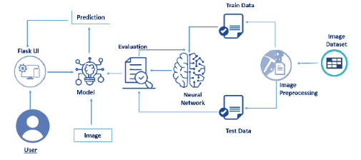

**SOFTWARE DESIGNING:**

To complete this project, you must require the following software’s,  concepts, and packages

1. Anaconda (IDLE / Spyder / PyCharm)(Python 3.7):

2.Python Packages

3.Tensorflow- This package is used as backend support to Keras

4.Keras-This package is used for building Neural Network layers

5.OpenCV-This package is used for image processing

6.Flask- To build a web application

EXPERIMENTAL INVESTIGATIONS:

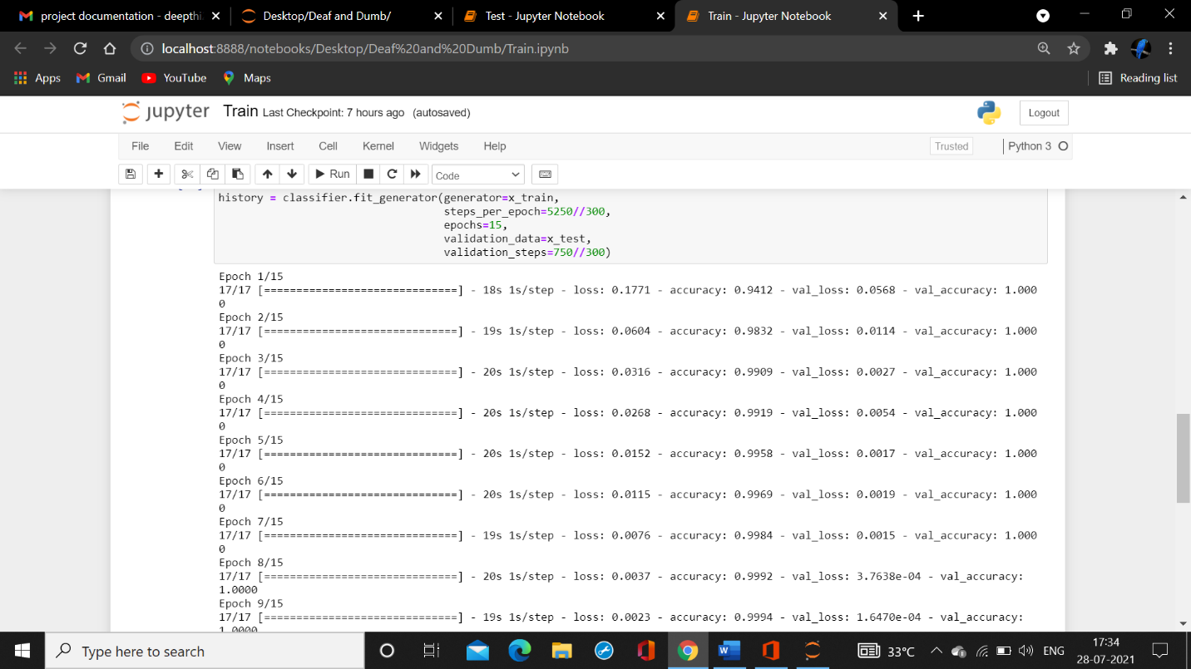

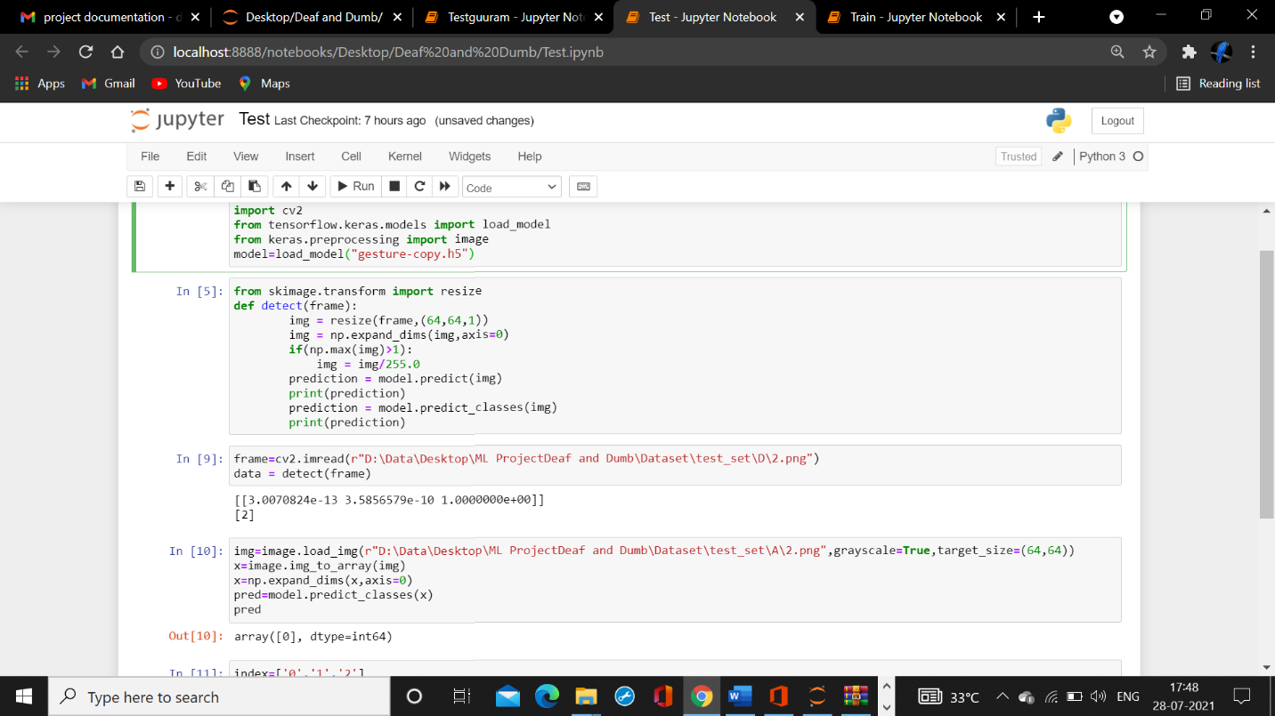

**FLOW CHART**

Understanding data

Data preprocessing

Training

testing

Results

RESULT:

This is the final output.

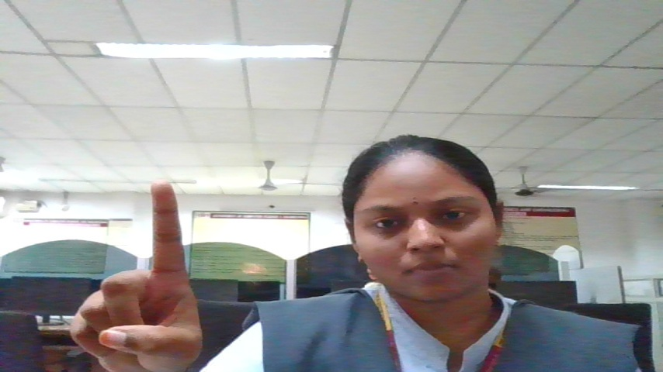

**ADVANTAGES AND DISADVANTAGES:**

**ADVANTAGES:**

It provides an environment for the user to send message through a sign language keyboard. It recognize the hand gestures of sign language through image processing.

Other feature converts the speech spoken into text .

DISADVANTAGES:

It has limitations sych as it cannot convert text to speech.

**APPLICATIONS:**

* to cater the needs of children who are non-verbal or are having speech problems.
* The app comes to the aid of mute, deaf and other non-verbal users when having a conversation with other people.

**CONCLUSION:**

We follow through the flowchart above where training, testing of the model is done and UI Part of the project includes HTML File and Python file.

**FUTURE SCOPE:**

Lot of developments can be made in the application such as adding feature like converting text to speech.

**BIBLIOGRAPHY:**

* Smartinternz.com
* Stackoverflow.com
* Images from google

Website page:

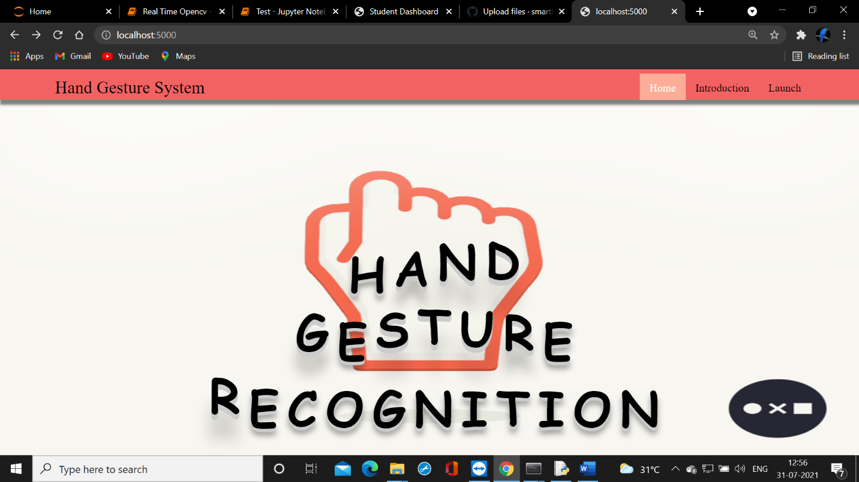



**LEARNING EXPERIENCES:**

As a team,we learnt

* How an app is built using html file and python file.
* How to train a model on IBM Watson.

THANK-YOU

CSE- 3B

TEAM- GRIPCIET-002